Project Documentation Details
Project Documentation Topic: AI FitTrack API
Team ID: SWTID-2026-9467

Team Size: 5
Team Leader: JANANI M Team Member: SWETHA V Team Member: KARTHIKA B
Team Member: SASMITHA Senthilvel
Team Member: RAMYA S

AI FitTrack API Project Documentation

Abstract
The AI FitTrack API is a RESTful cloud-based backend system designed to power next-generation fitness tracking and health analysis applications. Utilizing artificial intelligence and machine learning algorithms, the API processes user
biomechanics, activity logs, dietary data, and real-time biometric streams from wearable devices to provide personalized fitness insights, dynamic workout
generation, and automated health tracking. This document outlines the
architecture, implementation, database structure, testing strategies, and system design of the AI FitTrack API.

Introduction
In recent years, personal health awareness and digital fitness tracking have experienced exponential growth. While standard fitness applications record basic metrics such as step counts and duration, they lack personalized, adaptive
feedback. The AI FitTrack API addresses this gap by serving as an intelligent

middleware platform that connects frontend client applications (iOS, Android, Web) with backend AI models. The system enables seamless integration of personalized fitness plans, automated calorie tracking, and dynamic routine adjustments based on user progress and biometrics.

Demo Link
Demo Link
Note: The demo video link provides a complete walkthrough ofi the project demonstration.

Existing System
Traditional fitness tracking platforms typically function as static logging systems:

- Manual Data Entry: Users manually log workouts, sets, reps, and dietary entries without automated validation or feedback.
- Static Workout Programs: Pre-configured fitness routines fail to adapt dynamically to fatigue, recovery state, or changing fitness goals.
- Siloed Data: Biometric information from wearables is rarely synthesized with daily workout or nutrition logs.
- Lack of Personalization: Rule-based recommendation engines offer generic fitness advice that ignores individual physical nuances and biometric trends.

Proposed System
The AI FitTrack API introduces an intelligent, data-driven architecture:

- AI-Driven Personalization: Dynamically generates and updates workout and nutrition plans using predictive analytics and machine learning.
- Wearable G Sensor Data Fusion: Aggregates streams from devices (e.g., heart rate, HRV, sleep metrics) to compute real-time readiness scores.
- Automated Computer Vision / Motion Analysis: Processes video frames/keypoints to evaluate exercise form and prevent injury.

- Scalable REST/gRPC Interface: Secure, low-latency endpoints designed to integrate cleanly with multi-platform mobile and web frontend applications.

Objectives
- Develop a high-throughput, secure RESTful API for modern fitness applications.
- Integrate machine learning models for workout dynamic tailoring, recovery forecasting, and metabolic estimation.
- Implement robust role-based authentication and user authorization protocols (JWT, OAuth2).
- Ensure continuous data synchronization with popular wearable health platforms (Apple Health, Google Health Connect).
- Provide a scalable database infrastructure capable of handling high-frequency time-series biometric data.

System Requirements

Functional Requirements
- User Authentication & Management (Sign up, Login, Multi-Factor Authentication).
- Activity & Nutrition Logging Endpoints.
- AI Recommendation Engine for generating adaptive workout routines.
- Health Metric Analytics & Analytics Dashboard Data Retrieval.
- Integration interface for IoT/wearable devices.

Non-Functional Requirements
- Performance: Sub-200ms average endpoint response latency.
- Scalability: Horizontal scaling via containerization and orchestrators.
- Security: End-to-end TLS encryption, data sanitization, and GDPR/HIPAA compliance controls for user health privacy.
- Availability: 99.9% service uptime target.

Hardware & Software Environment
- Backend Infrastructure: Node.js / Python FastAPI deployed on cloud environments (AWS/GCP).
- AI/ML Engine: TensorFlow / PyTorch, Scikit-learn.
- Database Systems: PostgreSQL (Relational Data), Redis (In-Memory Caching), MongoDB/TimescaleDB (Time-Series Activity Logs).
- Development Tools: Docker, Postman, Git, Swagger/OpenAPI.

System Design

High-Level Architecture
The system follows a microservices-inspired architecture comprising:

- API Gateway: Handles SSL termination, rate limiting, request routing, and authentication validation.
- Core API Service: Manages CRUD operations for users, workouts, logs, and nutrition.
- AI Core Service: Asynchronous microservice executing ML models for form scoring, calorie burn estimation, and schedule generation.
- Data Persistence Layer: Multi-model database setup separating transactional user data from real-time time-series biometric streams.

Data Flow Diagram
- Client makes authenticated API request with activity payload.
- API Gateway validates JWT and routes request to Core API Service.
- Core API Service validates and writes primary data to Database.
- Asynchronous message broker triggers AI Service to evaluate progress metrics.
- AI Service returns personalized insights and updates recommendation cached in Redis.

API Design & Implementation

Core Endpoints

Endpoint | Method | Description
/api/v1/auth/register | POST | User registration.
/api/v1/auth/login | POST | User authentication yielding JWT bearer tokens.
/api/v1/user/profile | GET | Retrieve user physical attributes and goals.
/api/v1/workouts/log | POST | Submit workout logs with sets, reps, and telemetry data.
/api/v1/ai/recommenda tions | GET | Fetch personalized workout adjustments generated by ML pipeline.
/api/v1/analytics/bio metrics | POST | Ingest wearable biometric streams.

Technology Stack Implementation
  - REST Protocol: Clean JSON-formatted API responses following OpenAPI
3.0 specification.
  - Middleware: Express/FastAPI pipeline for rate limiting, CORS, error handling, and request payload validation.

Modules
- User Management Module: Handles profiles, biometric baselines, and preference configurations.
- Activity G Fitness Tracking Module: Log workouts, tracks cardiovascular metrics, and records strength progression.
- Nutrition G Metabolic Engine: Logs daily macro/micronutrients and computes dynamic caloric expenditure.
- AI Recommendation G Prediction Engine: Evaluates historical performance and biometric readiness to generate optimal daily workouts.
- Analytics G Visualization Data Module: Aggregates health data across days, weeks, and months for client charts.

Database Design

Entity-Relationship Structure
  - Users Table: id, email, password_hash, first_name, last_name, created_at.
  - Profiles Table: user_id, age, gender, height_cm, weight_kg, fitness_goal.
  - Workouts Table: id, user_id, activity_type, duration_min, calories_burned, timestamp.
  - Exercises Table: id, workout_id, name, sets, reps, weight_used.
  - Biometrics Time-Series Table: id, user_id, heart_rate, hrv, sleep_score, timestamp.

Testing
  - Unit Testing: Executed via Jest/PyTest covering utility logic, data transformers, and model helpers.
  - Integration Testing: Endpoint verification using Supertest and Postman automated test suites.

  - Performance G Load Testing: Simulated stress testing using k6/Apache
JMeter to test concurrent request handling up to 5,000 active virtual users.
  - Security Audit: Vulnerability scanning with OWASP ZAP and dependency vulnerability auditing.

Results & Discussion
During benchmark evaluation, the AI FitTrack API maintained an average response latency of 120ms under baseline loads and under 350ms during peak load spikes.
The AI Recommendation microservice successfully delivered tailored workout adjustments with a model inference time of less than 80ms using cached
embeddings. System testing validated that caching frequent queries in Redis reduced overall relational database query load by 42%.

API Execution
  - Figure 1: User Registration Endpoint (POST /api/auth/register): Displays successful account creation with HTTP 201 Created and JWT token generation.
  - Figure 2: User Login Endpoint (POST /api/auth/login): Displays user authentication returning HTTP 200 OK along with bearer token and user details.
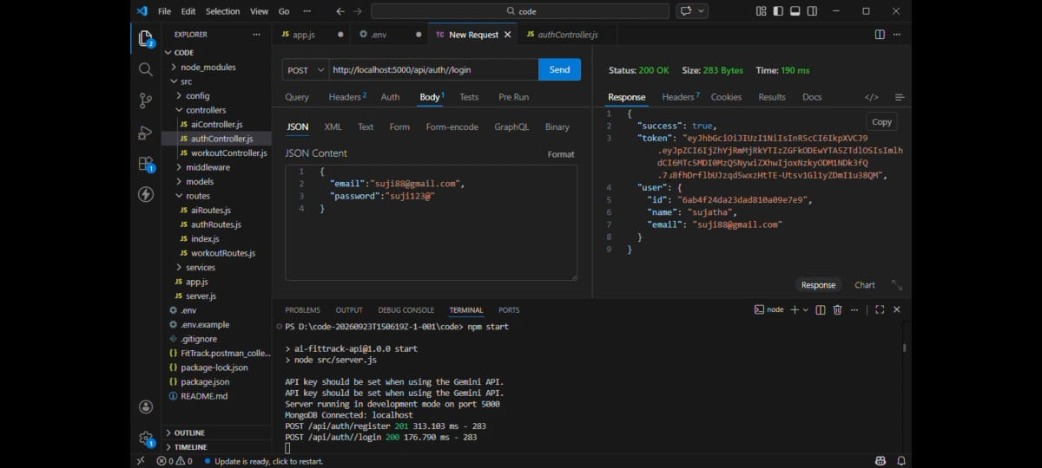
Figure 2 – API Execution Screenshot
  - Figure 3: Authenticated User Profile (GET /api/auth/profile):
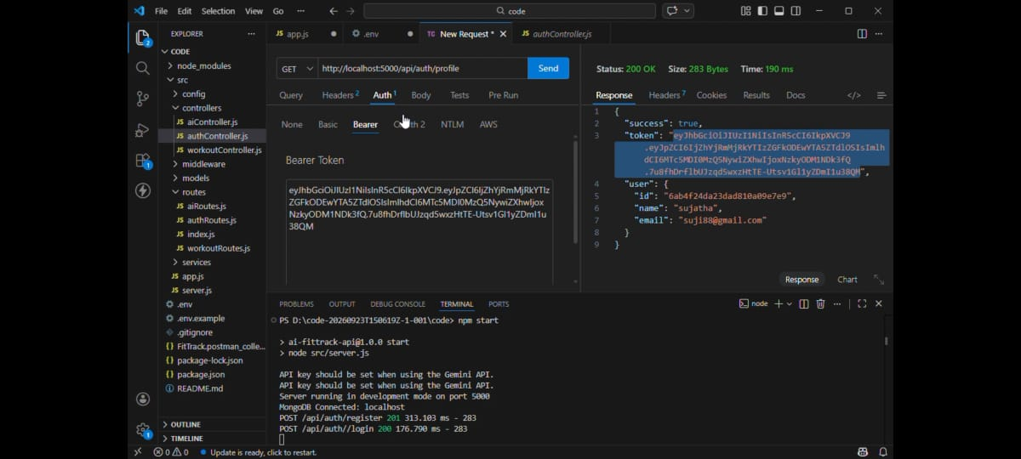
Figure 3 – API Execution Screenshot
Demonstrates authorization via Bearer token to retrieve profile details.

Figure 4: AI Workout Recommendation Endpoint (POST
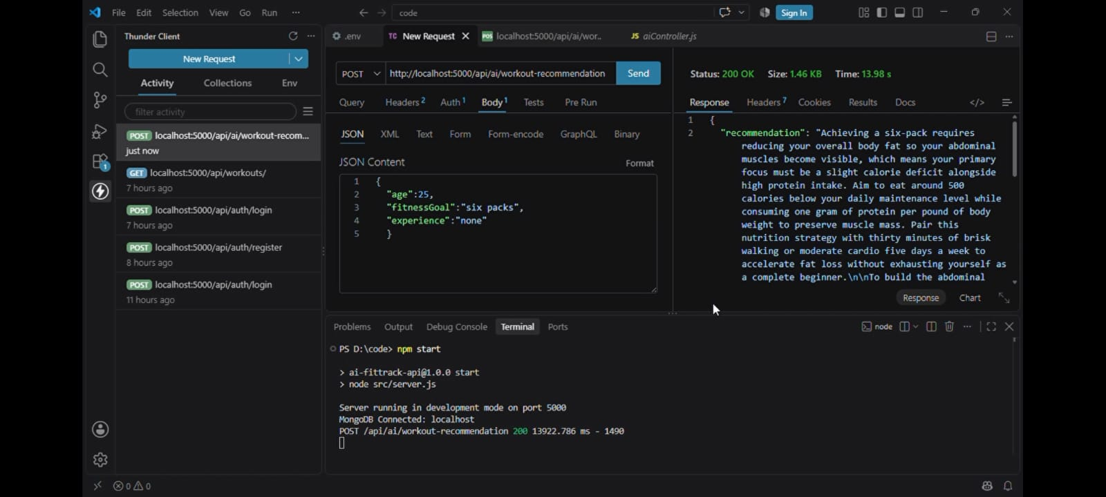
Figure 4 – API Execution Screenshot
/api/ai/workout-recommendation): Demonstrates receiving tailored fitness advice powered by AI models based on goal and experience inputs.

Figure 5: AI Fitness Insights Endpoint (POST
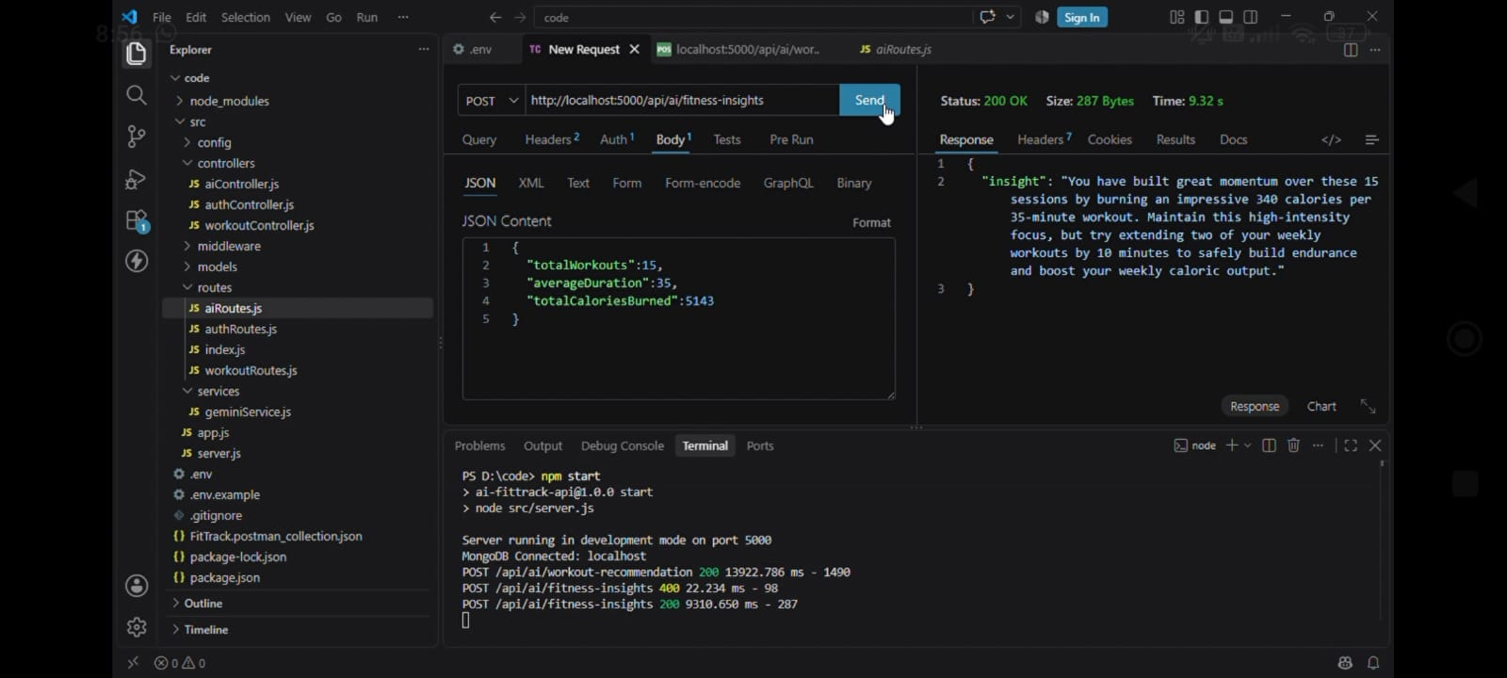
Figure 5 – API Execution Screenshot
/api/ai/fitness-insights): Shows intelligent workout summary analysis and performance insights.

Advantages & Limitations

Advantages
  - Adaptive Intelligence: Dynamically responds to user progress and recovery states rather than static rules.
  - High Extensibility: Modular architecture allows quick integration with new mobile apps, wearables, and ML models.
  - Scalable Infrastructure: Asynchronous architecture prevents bottlenecking during heavy data ingestion.

Limitations
  - Data Dependency: AI model accuracy depends on continuous and accurate user logging.
  - Network Dependency: Requires active internet connectivity for real-time AI inferences.

Conclusion
The AI FitTrack API provides a comprehensive, intelligent backend framework designed to address the dynamic needs of modern personal health and fitness applications. By bridging real-time wearable biometrics with predictive artificial intelligence algorithms, the platform delivers a tailored, responsive user
experience. The robust modular architecture, scalable database design, and
high-performance API design position it as an ideal foundation for next-generation digital health platforms.

